

**School of computer application**

Assignment : 6

of

Programming in Java - LAB (CAP 680)

**Session 2022-2024**

**Submitted to: Submitted by:**

Name: Mr. Prince Arora Name: Satyam Mishra

(Dept of. Computer Science) Reg. no: 12212256

Course: MCA

**Department of computer Science**

**Lovely Professional University Jalandhar Punjab (144401)**

**India.**

**Code**

import java.util.Scanner;

public class MyProgram {

public static void main(String[] args) {

Scanner sc = new Scanner(System.in);

System.out.print("Enter a number: ");

int num = sc.nextInt();

sc.close();

boolean isPowerOfTwo = (num > 0) && ((num & (num - 1)) == 0);

if (isPowerOfTwo) {

System.out.println(num + " is a power of 2.");

} else {

System.out.println(num + " is not a power of 2.");

}

}

}

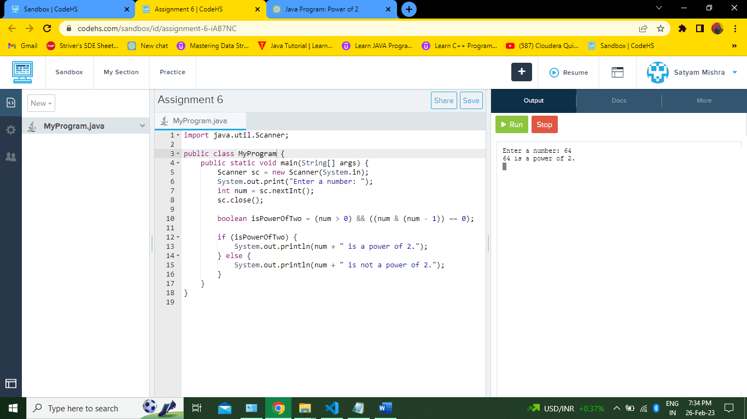**Output**

